Creating Collections
db.customers.insertMany([{customerId:1,firstName:"Ravi",lastName:"Kumar",dateOfBirth:ISODate("1995-06-15"),phone:"9876543210",email:"ravi@gmail.com"},{customerId:2,firstName:"Anita",lastName:"Sharma",dateOfBirth:ISODate("1992-03-10"),phone:"9123456789",email:"anita@gmail.com"}]);

db.agents.insertMany([{agentId:101,agentName:"Suresh Rao",phone:"9988776655",city:"Hyderabad"},{agentId:102,agentName:"Meena Patel",phone:"8877665544",city:"Mumbai"}]);

db.policies.insertMany([{policyId:201,policyName:"Health Plus",policyType:"Health",premiumAmount:12000,durationYears:5},{policyId:202,policyName:"Life Secure",policyType:"Life",premiumAmount:15000,durationYears:10}]);

db.policyAssignments.insertMany([{assignmentId:301,customerId:1,policyId:201,agentId:101,startDate:ISODate("2024-01-01"),endDate:ISODate("2029-01-01")},{assignmentId:302,customerId:2,policyId:202,agentId:102,startDate:ISODate("2023-06-01"),endDate:ISODate("2033-06-01")}]);

db.claims.insertMany([{claimId:401,assignmentId:301,claimDate:ISODate("2025-01-10"),claimAmount:50000,claimStatus:"Approved"},{claimId:402,assignmentId:302,claimDate:ISODate("2024-12-05"),claimAmount:75000,claimStatus:"Pending"}]);
1.db.customers.find()
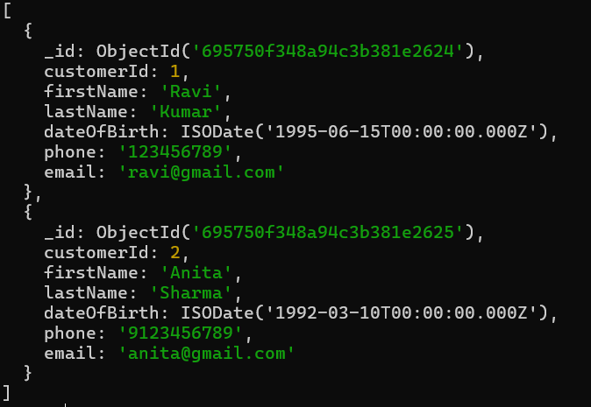
2.db.customers.find({ customerId: 1 })
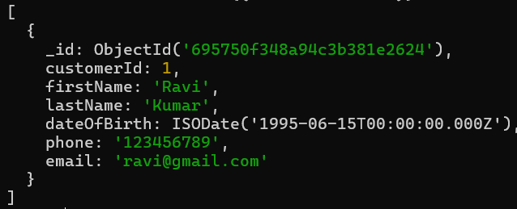
3.db.customers.find({
dateOfBirth: { $gt: ISODate("1993-01-01") }
})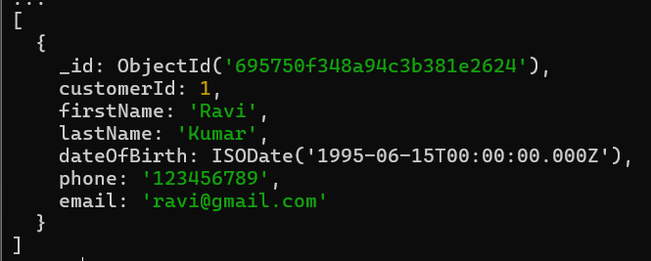
4. db.policies.find({ premiumAmount: { $gt: 13000 } })
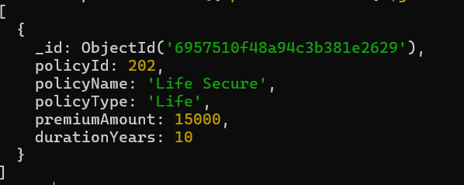
5.db.policies.find({
$or: [
{ policyType: "Life" },
{ premiumAmount: { $lt: 13000 } }
]
})
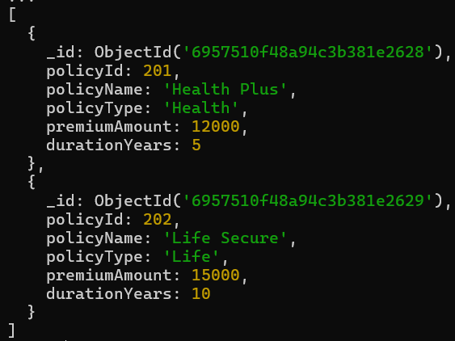
6. db.policies.find().sort({ premiumAmount: 1 })
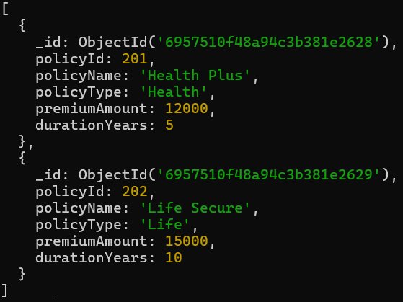
7. db.policies.find().sort({ premiumAmount: -1 })
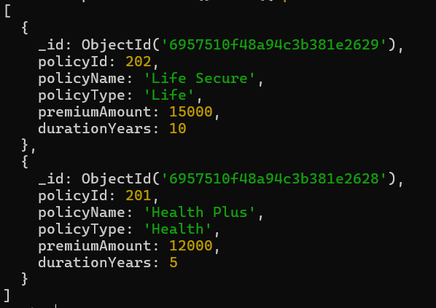
8.db.customers.find().limit(1)
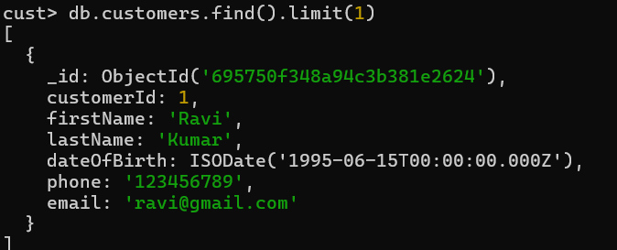

9. db.customers.find().skip(1)
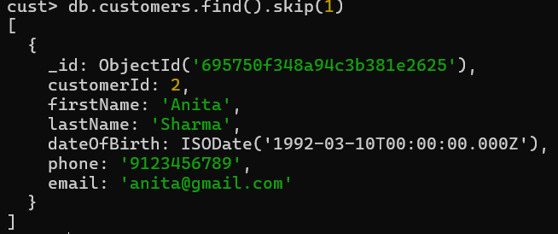

10. db.customers.updateOne(
{ customerId: 1 },
{ $set: { phone: "9000000000" } }
)
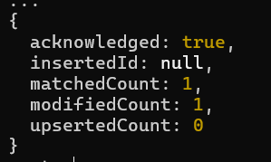
11. db.policies.updateMany(
{ policyType: "Health" },
{ $inc: { premiumAmount: 1000 } }
)
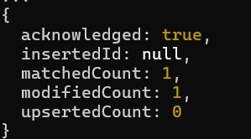
12. db.policies.updateMany(
{ policyType: "Health" },
{ $inc: { premiumAmount: 1000 } }
)
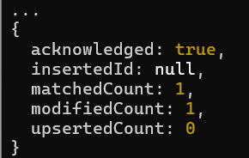
13. db.claims.deleteOne({ claimId: 402 })
14. db.policyAssignments.find({
endDate: { $gt: new Date() }
})
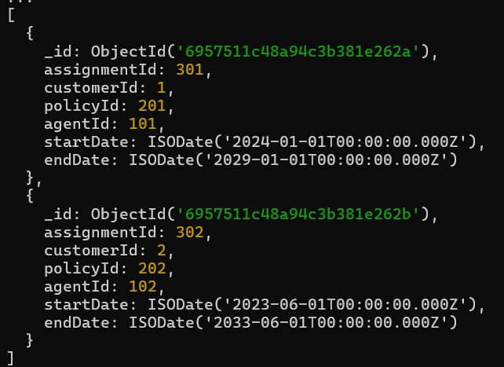
15. db.claims.aggregate([
{
$lookup: {
from: "policyAssignments",
localField: "assignmentId",
foreignField: "assignmentId",
as: "assignmentDetails"
}
}
])
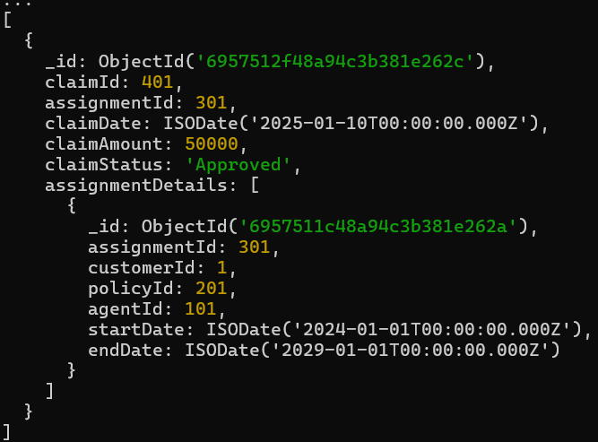

16. db.policyAssignments.aggregate([
{
$lookup: {
from: "customers",
localField: "customerId",
foreignField: "customerId",
as: "customerDetails"
}
}
])
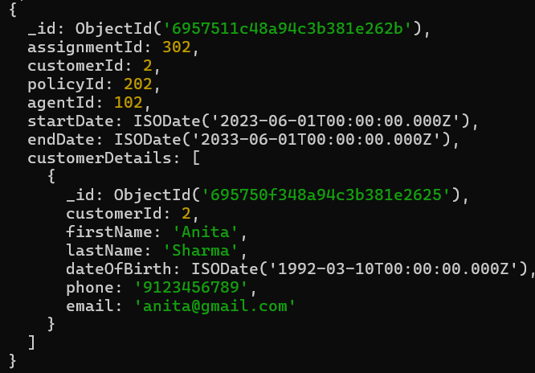
17. db.policies.aggregate([
{ $group: { _id: null, avgPremium: { $avg: "$premiumAmount" } } }
])

18. db.customers.countDocuments()
2
19. db.customers.find({email:/@gmail\.com$/});
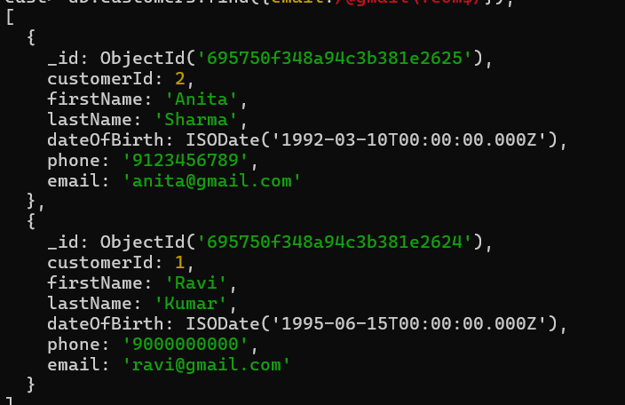

20.db.policyAssignments.find({agentId:{$in:[101,102]}});
